API Document Version 3

Release Date 10.13.2018

1. **PAN Information Verification**
   * Request Mechanism:
     + Send Individual Information for PAN No Search 3
   * Response Mechanism:
     + Post PAN Report through Call back URL 4
     + Get PAN Report through API 5
   * Test Case 6
   * **Send Individual Information for PAN No Search**

|  |  |  |  |  |
| --- | --- | --- | --- | --- |
| api ad- dress | **http://in.creditech.biz/pan/** | | | |
| method | **POST** | | | |
| Authorizati on | **user_name+License code** | | | |
| parameter | field name | field desc | field type | comments |
| **surname** |  | **String** |  |
| middle_name |  |  |  |
| first_name |  |  |  |
| status |  |  |  |
| gender |  |  |  |
| date_of_birth |  |  | dd/mmm/yyyy |
| pan_code |  |  |  |
| callbackURL | callbackURL |  |  |
|  |  |  |  |
| return | {“report_id:"222222", "status": "200"} | | | |
| status | * status:200 success * status:401 Unauthorized access (authorization key is not correct) | | | |
| Example | curl -i -u user_name:license_code-H "Content-Type: application/json" -X POST  -d ‘{json_format_data}’ **https://in.creditech.biz/pan/** | | | |

* Post PAN Report through callbackurl

|  |  |  |  |  |
| --- | --- | --- | --- | --- |
| api ad- dress | **callbackURL** | | | |
| method | **POST** | | | |
| Authorizati on |  | | | |
| parameter | field name | field desc | field type | comments |
| **report_id** |  | **String** |  |
| comment |  | **String** |  |
| status |  | **String** |  |
| gender |  | **String** |  |
| date_of_birth |  | **String** |  |
| surname |  | **String** |  |
| middle_name |  | **String** |  |
| first_name |  | **String** |  |
| pan |  | **String** |  |
| verified_info |  |  | Pan code is valid or not |
| return | {"status": "200"} | | | |
| Callbackk Con- tent | {"**report_id**": “**report_id**"， **“**comment”:” comment”, “status”: “status”,  ‘verified_info’: ‘Pan code is valid (or invalid)’  “gender”:” gender”,  “date_of_birth”:” date_of_birth”, “surname”:” surname”,  “middle_name”:” middle_name”, “first_name”:” first_name”, “pan”: “pan”} | | | |

|  |  |
| --- | --- |
| Example | curl -i -u user_name:license_code-H "Content-Type: application/json" -X POST -d ‘{json_format_data}’ **callbackurl** |

* Get PAN Report through API

|  |  |  |  |  |
| --- | --- | --- | --- | --- |
| api ad- dress | **https://in.creditech.biz/pan/report/** | | | |
| method | **POST** | | | |
| Authorizati on |  | | | |
| parameter | field name | field desc | field type | comments |
| **report_id** |  | **String** |  |
|  |  |  |  |
| return | {"**report_id**": “**report_id**"， **“**comment”:” comment”, “status”: “status”,  ‘verified_info’: ‘Pan code Mapping or Not’  “gender”:” gender”,  “date_of_birth”:” date_of_birth”, “surname”:” surname”,  “middle_name”:” middle_name”, “first_name”:” first_name”, “pan”: “pan”  } | | | |
| status | - status:200 success | | | |
| Example | curl -i -u user_name:license_code-H "Content-Type: application/json" -X POST -d ‘{json_format_data}’ **callbackurl** | | | |

* Test Case

Request:

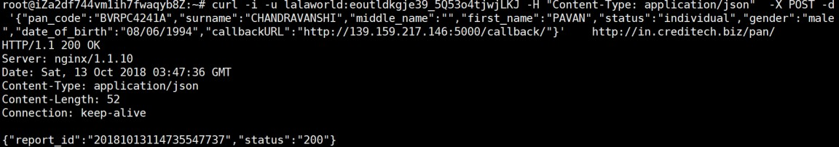

Response:

